1.Group Anagrams:
#code:
import java.util.*;
class Solution {
public List<List<String>> groupAnagrams(String[] strs) {
Map<String, List<String>> anagramMap = new HashMap<>();
for (String s : strs) {
char[] charArray = s.toCharArray();
Arrays.sort(charArray);
String sortedKey = new String(charArray);
if (!anagramMap.containsKey(sortedKey)) {
anagramMap.put(sortedKey, new ArrayList<>());
}
anagramMap.get(sortedKey).add(s);}
return new ArrayList<>(anagramMap.values());
}
}
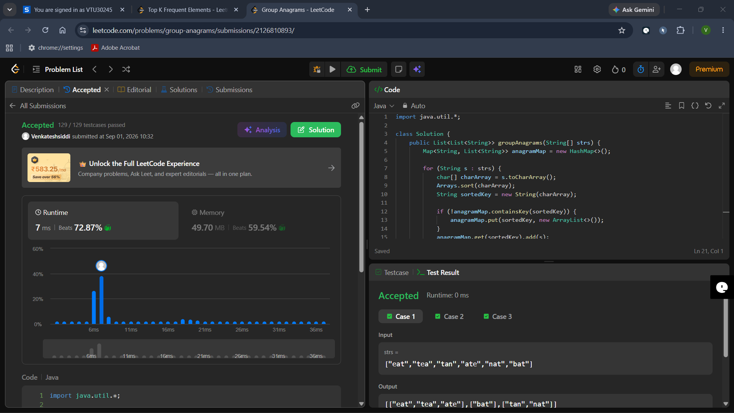
2. top-k-frequent-elements:
#code:
import java.util.*;

class Solution {
public int[] topKFrequent(int[] nums, int k) {
// Count frequencies
Map<Integer, Integer> count = new HashMap<>();
for (int num : nums) {
count.put(num, count.getOrDefault(num, 0) + 1);
}

// Create buckets where index = frequency
List<Integer>[] buckets = new List[nums.length + 1];
for (int key : count.keySet()) {
int frequency = count.get(key);
if (buckets[frequency] == null) {
buckets[frequency] = new ArrayList<>();
}
buckets[frequency].add(key);
}

// Collect top k frequent elements from right to left
int[] result = new int[k];
int index = 0;
for (int i = buckets.length - 1; i >= 0; i--) {
if (buckets[i] != null) {
for (int num : buckets[i]) {
result[index++] = num;
if (index == k) {
return result;
}
}
}
}
return result;
}
}

